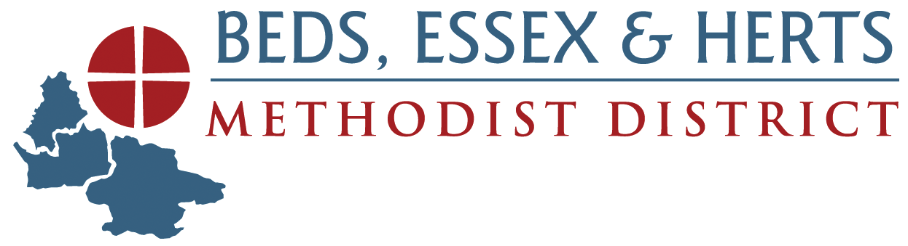

**THE METHODIST CHURCH - BEDS, ESSEX AND HERTS DISTRICT**

**BEYOND WARM SPACES - GRANT APPLICATION FORM**

As a result of feedback received about ongoing work that has continued as a result of Warm Spaces, the District is making additional grants available, which will be known as ‘Beyond Warm Spaces’ to local churches. The grant is for up to £1,000, payable on approval of the application, and CANNOT be applied for if a Warm Spaces grant for 2025/2026 has been approved.

Churches must demonstrate how their ongoing project morphed out of Warm Spaces and how they intend to continue.

|  |  |
| --- | --- |
| **About the Application** |  |
| Circuit | Church Name and Address |

|  |  |  |  |
| --- | --- | --- | --- |
| **About the Correspondent** |  |  |  |
| Correspondent’s name |  | Address (including postcode) |  |
| Telephone number |  | E-mail |  |

|  |
| --- |
| **About the Grant** |
| Please explain how the church intends to use the Beyond Warm Spaces grant, including how it morphed out of Warm Spaces, over the period September 2024 to August 2025. Also please include the value of grant being requested. |
| Name, Account Number and Sort Code of Church bank account: |
| Date when church registered with www.warmwelcome.uk (Required) |
| We confirm that:   * the local Church named in this application has registered with warmwelcome.uk. * the application is for an ongoing project that has morphed from the Warm Spaces initiative. * the grant will be used exclusively for this purpose. * a new Warm Spaces grant has not been applied for.   Name of Minister in pastoral charge:  Signature Date  Name of Superintendent  Signature Date |
| Completed application forms can be scanned and sent by email to the District Grants Secretary, Mr Tony Trevers, at [grants@behdistrict.org.uk](mailto:grants@behdistrict.org.uk).  Grants will be paid by cheque within 14 days of approval. |
| **For District use:**  Date Application Received:  Date Application Approved: |